

Higher Technological Institute

Faculty of Engineering

Mechatronics Department

Engine Control Unit   
[ECU]

Graduation Project Submitted By:

Omar Abdelghany Ahmed 20160603

Mohamed Yehia Shaaban 20160927

Donia Khaled Amer 20160368

Ahmed Ashraf Abdel-Aziz 20160036

Ali Tarek Abdel-hai El Hadidy 20160563

Omar Adel Ahmed Mohamed 20160601

Mohamed Mostafa Abdel-Mawgood 20160908

Under the supervision of

Dr. Amal Ibrahim

July 2021

# ACKNOWLEDGEMENT

Praise to ALLAH, All Mighty, by whose grace this work has been done.

Our gratitude goes to our project supervisor Dr. Amal Ibrahim.

We would like to express our very great appreciation to Technician Reda and the Whole crew for Supporting our project and providing us with the technical information.

We would like to offer our special thanks to each and every person who assisted us by putting their work and guidance on the internet in an open-source format including: ResearchGate.net, Lucas Sangoi Mendonça.

We wish to acknowledge every entity that made the components for the project available for purchase or provided us with guidance from where to buy them: Kitchen Maker Space, RAM Electronics, Free Electronics.

We are extremely grateful to our parents and families for their continuous love, prayers, sacrifice, care and support. This whole project would not have been possible without them.

# ABSTRACT

Electronic devices in automotive area have been used on large scale and a control unit is mandatory for greater engine efficiency. By performing the spark advance and injection timing correctly in internal-combustion engines, an engine control unit improves drivability and helps to reduce fuel consumption.

This paper presents hardware development, software coding using embedded C programming language for an ATmega128 - 8-bit AVR Microcontroller. The injection flow rates were measured and calibrated with the calculated fuel flow rates for different equivalence ratios of the engine.

**TABLE OF CONTENTS**

# Ch.1

# Introduction

Internal-combustion engines create power by burning fuel mixed with air, that is, chemical energy from air-fuel mixture is converted into kinetic energy providing torque. For many decades, carburetors has powered gasoline engines, however, considering their difficulty for precise fuel metering and environmental concerns, they have become obsolete.

Electronic devices in automotive area have been used on a large scale, and a control unit is mandatory for greater engine efficiency. Utilizing microcomputers, developed a universal control unit (UCU), a data acquisition unit (DAU) and an engine simulation unit (ESU) for an overall engine control development system.

An engine control unit or electronic control unit (ECU) is a system on which the timing of the injection, the amount of fuel that is injected and the spark advance (for gasoline engines) are calculated, and its development has been reported in literature.

Electronic components incorporated in cars help to reduce emission of pollutant, improve drivability and reduce fuel consumption, furthermore, with the embedded systems growth, powerful electronic control systems were applied for internal-combustion engines, considering that modern cars incorporate approximately one third of their parts in electronic components.

The ECU of an internal-combustion engine is a microprocessor that receives input signals from the engine and executes various tasks. the main output signals from ECU are the injection and ignition command. The signal for injection is a pulse-width signal with duty cycle related to injection timing according to injection map. The ignition system generates a very high voltage and sends it to each sparkplug which introduces energy into the chamber and produces a spark between the electrodes, initializing combustion.

The ECU receives the signals from the sensors, processes data and realizes calculations to generate output signals for the actuators. A software program is stored in ECU´s memory and is executed by a microcontroller that realizes tasks in order to improve efficiency.

This paper presents an automotive engine control unit development considering the architecture of tasks for spark advance and injection timing using embedded C programming language for an ATmega128 - 8-bit AVR Microcontroller.

# Ch.2

# ECU

## 2.1 Interior Combustion.

**2.1.1 Introduction and operating cycles**

The reciprocating internal combustion engine must be by far the most common form of engine or prime mover. As with most engines, the usual aim is to achieve a high work output with a high efficiency; the means to these ends are developed throughout this book. The term “Internal Combustion Engine” should also include open circuit gas turbine plant where fuel is burnt in a combustion chamber. However, it is normal practice to ignore the prefix “reciprocating”; none the less this is the key principle that applies to both engines of different types and those utilizing different operating principles. The divisions between engine types and between operating principles can be explained more clearly. The modern motor vehicle engine burns a fuel to obtain power. The fuel is usually petrol (gasoline) or diesel. Motor vehicle engines are known as “Internal Combustion” engines since the energy from the combustion of the fuel, and the resulting pressure from expansion of the heated air and fuel charge, is applied directly to pistons inside closed cylinders in the engine. The term “reciprocating piston engine” describes the movement of the pistons, which go up and down in the cylinders. The pistons are connected by a rod to a crankshaft to give a rotary output. Fig 1. However, the two main types of internal combustion engines are: spark ignition (SI) engines, where the fuel is ignited by a spark; and compression ignition (Cl) engines, where the rise in temperature and pressure during compression is sufficient to cause spontaneous ignition of the fuel. The spark ignition engine is also referred to as the petrol, gasoline or gas engine from its typical fuels, and the Otto engine, the compression ignition engine is also referred to as the Diesel or oil engine. During each crankshaft revolution there are two strokes of the piston, and both types of engines can be designed to operate in either four strokes or two strokes of the piston.

Figure Internal combustion engine internal components: crankshaft, connecting rods, pistons, valves, camshafts

**2.1.2 The four-stroke operating cycle**: it can be explained in figures (2-5). Fuel is metered into the engine together with an air charge for most petrol engines. However, some now use injectors that inject directly into the engine cylinder. In diesel engines, the fuel is injected into a compressed air charge in the combustion chamber. In order for the air and fuel to enter the engine and for the burnt or exhaust gases to leave the engine, a series of ports is connected to the combustion chambers, The combustion chambers are formed in the space above the pistons when they are at the top of the cylinders. Valves in the combustion chamber at the ends of the ports control the air charge and exhaust gas movements into and out from the combustion chambers. The valves are described as “poppet” valves and have a circular plate at right angles to a central stem that runs through a guide tube. The plate has a chamfered sealing face in contact with a matching sealing face in the port. The valve is opened by a rotating cam and associated linkage. It is closed and held closed by a coil spring. The opening and closing of the valves and the movement of the pistons in the cylinders follow a cycle of events called the “Four-stroke cycle” or the “Otto cycle” after its originator (Figs 2-5).



Figure Induction or intake: piston moving down



Figure Compression: piston moving up



Figure Power or combustion: piston is forced down



Figure Exhaust: piston moving back up

* **Intake stroke.**

The first stroke of the four-stroke cycle is the induction or intake stroke. This occurs when the piston is moving down in the cylinder from top dead Centre (TDC) to bottom dead Centre (BDC) and the inlet valve is open, and the piston travels down the cylinder, drawing in a charge of air. In the case of a spark ignition engine the fuel is usually pre-mixed with the air. The movement of the pistons increases the volume of the cylinder so that air and fuel enter the engine.

* **Compression stroke.**

The next stroke is the compression stroke, when the piston moves upwards in the cylinder. Both the inlet and exhaust valves are closed and the space in the cylinder above the piston is reduced. This causes the air and fuel charge to be compressed, which is necessary for clean and efficient combustion of the fuel. Towards the end of the compression stroke.

* **Power stroke.**

The fuel is ignited and burns to give a large pressure rises in the cylinder above the piston. This pressure rises forces the piston down in the cylinder on the combustion or power stroke.

* **Exhaust stroke.**

Once the energy from the fuel has been used, the exhaust valve opens so that the waste gases can leave the engine through the exhaust port. To complete the exhausting of the burnt gases the piston moves upward in the cylinder. This final stroke is called the exhaust stroke. The four-stroke cycle then repeats over and over again, as the engine runs.

A heavy flywheel keeps the engine turning between power strokes. On the induction stroke of a petrol engine (most types), air and petrol enter the cylinder so the inlet valve in the inlet port must be open. While in diesel, and gasoline (petrol) direct injection engines, only air enters the cylinder. A rotating cam on the camshaft provides a lifting movement when it runs in contact with a follower. A mechanical linkage is used to transfer the movement to the valve stem and the valve is lifted off its seat so that the inlet port is opened to the combustion chamber. The air and fuel charge or air charge can now enter the cylinder. The inlet valve begins to open shortly before the piston reaches TDC. The exhaust valve, which is operated by its own cam in the same way as the inlet valve, is beginning to close as the piston passes TDC at the end of the exhaust stroke. Valve overlap helps clear the remaining exhaust gases from the combustion chamber. The incoming air charge fills the combustion chamber as the last quantity of exhaust gas leaves through the exhaust port. This is known as “scavenging”; it helps cool the combustion chamber by removing hot exhaust gases and gives a completely fresh air charge. All internal combustion engines have an induction, compression, expansion and exhaust process. For a four-stroke engine, each of these processes requires half an engine revolution, so the complete engine cycle takes two complete engine revolutions.



Figure Petrol engine indicator diagram: 1- Introduction; 2-Compression; 3-Power 4- Exhaust.

The combustion process creates energy within the cylinder in the form of heat from the burning fuel/air mixture. Owing to the enclosed nature of the cylinder, this heat energy creates a pressure rise in the cylinder above the piston. This pressure, applied over the piston area, in turn, creates a force pushing down on the piston and turning the crankshaft via the connecting rod, thus producing torque at the crankshaft. The pressure in the cylinder is shown plotted against cylinder volume in Fig.6. This is known as an indicator diagram.

**2.1.3 Intake manifold.**

The intake manifold is a system designed to deliver air to the engine through pipes to each cylinder, called runners. The inside diameter of the runners must be large enough so that a high flow resistance and the resulting low volumetric efficiency do not occur. On the other hand, the diameter must be small enough to assure high air velocity and turbulence, which enhances its capability of carrying fuel droplets and increases evaporation and air-fuel mixing. The length of a runner and its diameter should be sized together to equalize, as much as possible, the amount of air and fuel that is delivered to each separate cylinder. The amount of air and fuel in one runner length is about the amount that gets delivered to one cylinder each cycle. On SI engines, air flow rate through the intake manifold is controlled by a throttle plate (butterfly valve) usually located at the upstream end. The throttle is incorporated into the carburetor for those engines so equipped. Fuel is added to inlet air somewhere in the intake system-before the manifold, in the manifold, or directly into each cylinder. It is found that when fuel is added early in the intake system, the flow of fuel through the manifold occurs in three different manners. Fuel vapor mixes with the air and flows with it. Very small liquid fuel droplets are carried by the air flow, smaller droplets following the streamlines better than larger droplets.

* **Definitions.**

**Spark Ignition (SI):** An SI engine starts the combustion process in each cycle by use of a spark plug. The spark plug gives a high-voltage electrical discharge between two electrodes which ignites the air-fuel mixture in the combustion chamber surrounding the plug. In early engine development, before the invention of the electric spark plug, many forms of torch holes were used to initiate combustion from an external flame.

**Compression Ignition (CI**): The combustion process in a CI engine starts when the air-fuel mixture self-ignites due to high temperature in the combustion chamber caused by high compression.

**Four-Stroke Cycle**: A four-stroke cycle experiences four piston movements over two engine revolutions for each cycle.

**Reciprocating**: Engine has one or more cylinders in which pistons reciprocate back and forth. The combustion chamber is located in the closed end of each cylinder. Power is delivered to a rotating output crankshaft by mechanical linkage with the pistons.

**Top-Dead-Center (TDC)**: Position of the piston when it stops at the furthest point away from the crankshaft. Top because this position is at the top of most engines (not always), and dead because the piston stops at this point. Because in some engines top-de ad-center is not at the top of the engine.

**Bottom-Dead-Center (BDC)**: Position of the piston when it stops at the point closest to the crankshaft.

**Direct Injection (DI)**: Fuel injection into the main combustion chamber of an engine.

**Stroke**: Movement distance of the piston from one extreme position to the other: TDC to BDC or BDC to TDC.

**Clearance Volume**: Minimum volume in the combustion chamber with piston at TDC.

**Smart Engine**: Engine with computer controls that regulate operating characteristics such as air-fuel ratio, ignition timing, valve timing, exhaust control, intake tuning, etc. Computer inputs come from electronic, mechanical, thermal, and chemical sensors located throughout the engine.

**Engine Management System (EMS)**: Computer and electronics used to control smart engines.

**Camshaft**: Rotating shaft used to push open valves at the proper time in the engine cycle.

**Combustion chambers**: The end of the cylinder between the head and the piston face where combustion occurs. The size of the combustion chamber continuously changes from a minimum volume when the piston is at TDC to a maximum when the piston is at BDC. The term "cylinder" is sometimes synonymous with "combustion chamber".

**Exhaust**: system Flow system for removing exhaust gases from the cylinders.

**Fuel injector**: A pressurized nozzle that sprays fuel into the incoming air on (SI) engines. The fuel injectors are located at the intake valve ports on multipoint port injector systems and upstream at the intake manifold inlet on throttle body injector systems. In a few SI engines, injectors spray directly into the combustion chamber.

**Fuel pump:** Electrically or mechanically driven pump to supply fuel from the fuel tank (reservoir) to the engine. Many modern automobiles have an electric fuel pump mounted submerged in the fuel tank.

**Piston**: The cylindrical-shaped mass that reciprocates back and forth in the cylinder, transmitting the pressure forces in the combustion chamber to the rotating crankshaft. The top of the piston is called the crown and the sides are called the skirt. The face on the crown makes up one wall of the combustion chamber and may be a flat or highly contoured surface. Some pistons contain an indented bowl in the crown, which makes up a large percent of the clearance volume. Pistons are made of cast iron, steel, or aluminum.

**Piston rings**: Metal rings that fit into circumferential grooves around the piston and form a sliding surface against the cylinder walls.

**Spark plug**: Electrical device used to initiate combustion in an SI engine by creating a high-voltage discharge across an electrode gap.

2.2.4 **ENGINE EMISSIONS AND AIR POLLUTION.**

Air pollution was recognized as a major problem in most cities around the world. However, four major emissions produced by internal combustion engines are hydrocarbons (HC), carbon monoxide (CO), oxides of nitrogen (NOx), and solid particulates (lead). Anyways, there are two methods, which are being used to reduce harmful engine emissions. One is to improve the technology of engines and fuels so that better combustion Occurs and fewer emissions are generated. The second method is after treatment of the exhaust gases. This is done by using thermal converters or catalytic converters. By using the first method which is by using the ECU to determine the best timing for fuel injecting so that the fuel is not wasted or harmful.

## 2.2 ECU.

As the requirements for lower and lower emissions continue, together with the need for better performance, other areas of engine control are constantly being investigated. This control is becoming even more important as the possibility of carbon dioxide emissions being included in future regulations increases. Some of the current and potential areas for further control of engine operation are included

In this section, some aspects in more detail and introduce further areas of engine control. Some of the main issues are:

• Ignition timing

• Dwell angle

• Fuel quantity

• Exhaust gas recirculation (EGR)

• Idle speed.

An engine management system can be represented by the standard three stage model, as shown in Figure 7.



Figure Representation of complete engine control as the standard

This representation shows closed loop feedback, which is a common feature, particularly related to:

• Lambda control (Air-Fuel ratio).

• Knock.

• Idle speed.

While, the block diagram shown as Figure 8 can further represent an engine management system. This series of “inputs” and “outputs” is a good way of representing a complex system. This section continues with a look at some of the less common “inputs and outputs”.



Figure General block diagram of an ignition and fuel control system

2.2.1. **Electronic control unit (ECU).**

The ECU is based on digital electronics. There is an advantage of controlling injection and ignition by a single ECU lies in the use of common sensors. Certain sensor signals are analogue in form and must be converted to a digital equivalent. For this purpose, an analogue to digital converter is used and will convert such quantities as battery voltage, temperature sensor voltages, etc. into pulses which represent them in digital fort-n. Sensors which already give a pulsating signal like engine speed and crankshaft position units, have inputs into pulse-shaping circuits. These circuits process the signals into sharp clean pulse waveforms, suitable for passing into the micro-computer.

2.2.2 **Ignition control angle**.

Correct ignition timing over the entire engine operating range is very important as t has a major impact on fuel consumption as well as on emission rates. Combustion within the cylinder can be divided into two phases:

1. Inflammation delay:

Which is time proportional.

1. Combustion angle proportional:

The equivalent crankshaft angle for the second phase is almost constant¸ over the entire engine operating range. Induced by the piston movement, turbulences accelerator with engine speed, as well as the combustion process.

2.2.3 **Why computers?**

As computers can carry out explicit instructions with blinding speed and almost flawless consistency. And much more precise way to control engine functions, or engine calibration. The automotive industry had already looked to microprocessors—processors contained on integrated circuits. Volkswagen introduced the first large-scale production, computer-controlled electronic fuel injection (EFI) system. These small computers, with their comparatively low cost, compact size and weight, great speed, and application flexibility, proved to be ideal for the industry. Probably the most amazing feature of the digital computer is its speed. Ultimately, there are five reasons why computers are being used to control so many systems on the automobile, including both engine management systems and non-engine systems. When compared to mechanical methods of control, computers provide:

• More precise control.

• Faster response.

• Increased dependability.

• The potential to add additional features and functions.

• Enhanced diagnostic capabilities.

2.2.4 **How computers work??!**

* **Communication signals.**

A computer uses voltage values or voltage pulses as communication signals; thus, voltage is often referred to as a signal or a voltage signal. There are two types of voltage signals: analog and digital (Figure 9). An analog signal’s voltage is continuously variable within a given range, and time is needed for the voltage to change. An analog signal is generally used to convey information about a condition that changes gradually and continuously within an established range. On and off creates a digital signal; voltage is either there or it is not. Digital signals are often referred to as square wave signals.

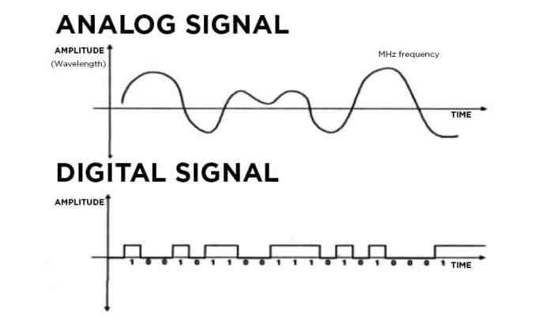

Figure Analog signals can be constantly variable. Digital signals are either on/off or low/high.

* **Baud Rate**.

The frequency of the bits of binary code as they are communicated is known as the computer’s baud rate. Baud rate is expressed in bits per second (b/S), kilobits per second (Kb/S), or megabits per second (Mb/S).

* **Internal Circuits of the Computer.**

Microprocessor or Central Processing Unit (CPU). The microprocessor (an IC chip), also referred to as the central processing unit (CPU), is the heart of a computer and has the task of making all decisions to be made by the computer. The CPU records input information. It then compares this information with the internal programs. This results in a specific response on the output side of the computer. It then sends the proper commands to control the output circuits appropriately. In essence, the CPU per forms the data processing of the computer. Interface. The microprocessor makes all of the decisions, but it relies on several support functions, one of which is the interface. A computer has an input interface and an output interface, The interface has two functions: It protects the delicate electronics of the microprocessor from the higher voltages of the circuits attached to the computer, and it translates input and output signals. The input interface translates all sensor input data (including DC analog signals, AC analog signals, and variable digital frequency signals) to digital binary code. It is sometimes referred to as the analog-to digital or A/D, converter. The output interface, or D/A converter, translates digital binary signals to analog to control the actuators and other output signals. The transistors that control the outputs are located in the output interface and are called drivers. The microprocessor of a computer performs the calculations and makes all of the decisions, but it cannot store information. The computer is therefore equipped with information storage capability called memory There are two ways that computer memories are classified: An IC memory chip may be in the form of either read only memory (ROM) or random-access memory (RAM), and this memory chip may be classified as either volatile or nonvolatile.

2.2.5 **Engine control and diagnosis**.

The electronic engine control unit (ECU) has the task to control, optimize and supervise all relevant functions of an internal combustion engine (ICE). At first glance this comprises:

• torque generation according to the driver’s accelerator pedal.

• Low fuel consumption.

• Low exhaust emissions and low noise (compliance with legislation).

• Good driving behavior.

With regard to the general assembly of internal combustion engines the control functions can be dedicated to following engine subsystems or engine parts:

1. Intake system (air system).

2. Injection system.

3. Fuel supply.

4. Combustion and crankshaft drive.

5. Lubrication.

6. Exhaust gas system.

7. Cooling system.

2.2.6 **Combined control of ignition and fueling.**

The motor vehicle spark ignition engine has two supplying units for the production of power, one being the supply of atomized fuel in correct quantity and air: fuel ratio, the other being the supply of an igniting spark at the correct timing. For most of this century, covering the span of motor vehicle design, these two provisions of fueling and sparks have been dealt with separately. It will be noted that performance requirements, in line with emission regulations show that these are not separate subjects but are inter-dependent; the fact that a change in air: fuel ratio should have a corresponding change in ignition timing is an example. Digital electronic ignition circuits use a micro-processor (computer) for control of ignition sparks, and fuel injection also uses a micro-processor. There is spare capacity on one micro-processor, however, to analyze inputs and control outputs for both ignition and fueling, this being the basis for an engine management system. Using one central micro-processor for the control of other operations in addition to ignition and fueling leads to the concept of a total electronic management System (TECMS) in which, for example, the computing facility is applied to steering and suspension, gear change in automatic boxes, automatic fault diagnosis and control of clutch lock-up operation. Such a system would incorporate a fail-safe provision in the event of Computer failure. The single computer control of ignition and fueling is the main purpose of this paragraph, however, for such a system is now in wide use.

# Ch.3

# Hardware

**3.1 Mechanical**

**3.2 Electrical**

**3.3 Electronics**

## 3.1 Mechanical

2.1.1 Internal Combustion Engine

An internal combustion engine (ICE) is a heat engine in which the combustion of a fuel occurs with an oxidizer (usually air) in a combustion chamber that is an integral part of the working fluid flow circuit. In an internal combustion engine, the expansion of the high-temperature and high-pressure gases produced by combustion applies direct force to some component of the engine. The force is applied typically to pistons, turbine blades, a rotor, or a nozzle.

2.1.2 Engine Parts

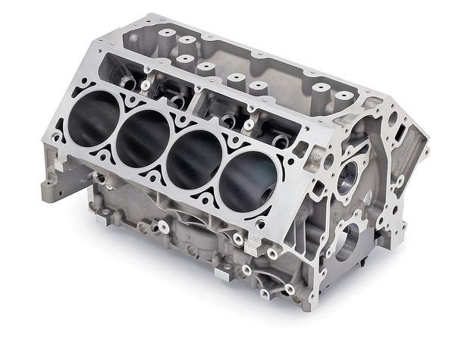2.1.2.1 Engine Block

An engine block is the structure which contains the cylinders, and other parts, of an internal combustion engine. In an early automotive engine, the engine block consisted of just the cylinder block, to which a separate crankcase was attached.

Modern engine blocks typically have the crankcase integrated with the cylinder block as a single component. Engine blocks often also include elements such as coolant passages and oil galleries.

Figure 1 : Engine Block

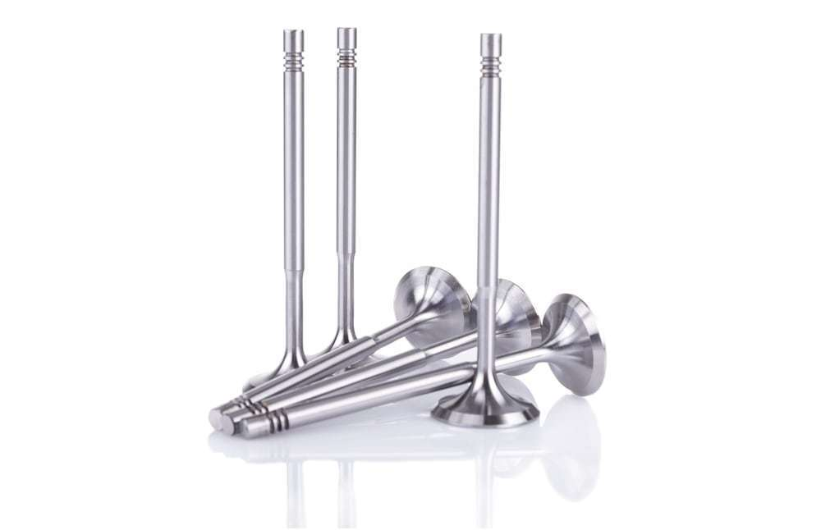2.1.2.2 Valves

Engine valves are mechanical components used in internal combustion engines to allow or restrict the flow of fluid or gas to and from the combustion chambers or cylinders during engine operation.

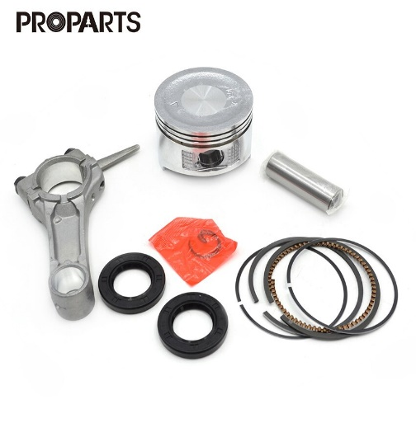2.1.2.3 Pistons and Connecting rod

Figure 2 : Valves

It is the moving component that is contained by a cylinder and is made gas-tight by piston rings. In an engine, its purpose is to transfer force from expanding gas in the cylinder to the crankshaft via the connecting rod. The Piston ring is a metallic split ring that is attached to the outer diameter of a piston in an internal combustion engine.

Figure 3 : Piston, rings & connecting rod

Figure 4 : Piston, rings & connecting rod

The main functions of piston rings in engines are:

* Sealing the combustion chamber so that there is minimal loss of gases to the crank case.
* Improving heat transfer from the piston to the cylinder wall.
* Maintaining the proper quantity of the oil between the piston and the cylinder wall
* Regulating engine oil consumption by scraping oil from the cylinder walls back to the sump.

2.1.2.4 Crankshaft

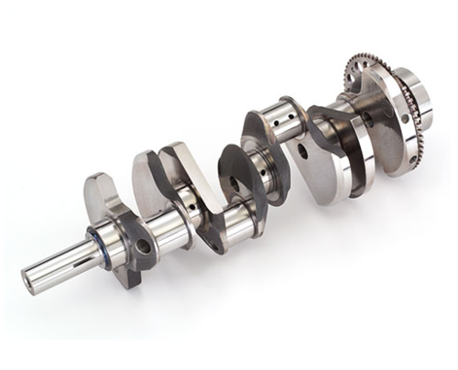A crankshaft is a rotating shaft which (in conjunction with the connecting rods) converts reciprocating motion of the pistons into rotational motion. Crankshafts are commonly used in internal combustion engines and consist of a series of cranks and crankpins to which the connecting rods are attached.

Figure 5: Crankshaft

2.1.2.5 Camshaft

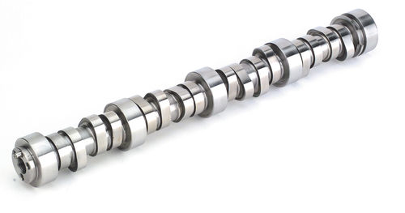A camshaft is a rotating object usually made of metal that contains pointed cams, which converts rotational motion to reciprocal motion. Camshafts are used in internal combustion engines (to operate the intake and exhaust valves)

Figure 6: Camshaft

2.1.2.6 Cylinder Head and its Gasket

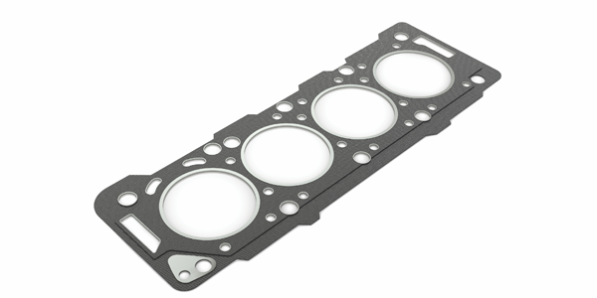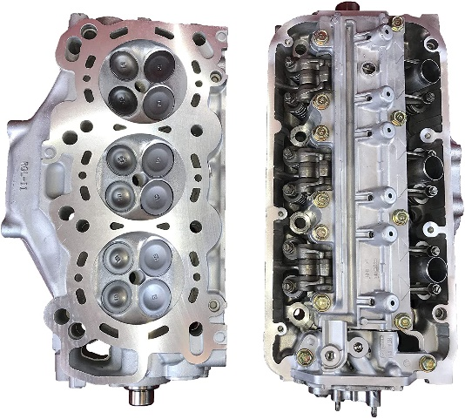In an internal combustion engine, the cylinder head contains the valves and sits above the cylinders on top of the cylinder block. It closes in the top of the cylinder, forming the combustion chamber. This joint is sealed by a head gasket that sits between the engine block and cylinder head(s) in an internal combustion engine. Its purpose is to seal the cylinders to ensure maximum compression and avoid leakage of coolant or engine oil into the cylinders.

Figure 7: Cylinder Head & its Gasket

2.1.2.7 Timing Gears, Timing Belts and Chains

* 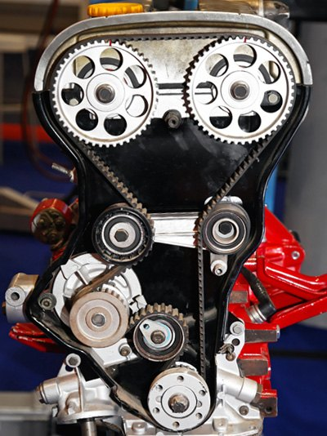Timing gears: They are two, the first gear on the front of the crankshaft is in constant mesh with the second gear on the front of the camshaft.
* Timing Belts: In recent times, many engine manufacturers have reverted to timing belts. There are many advantages to using timing belts: they are quiet; manufacture and assembly are easier because they can sit 'outside' the engine, as oil is not needed for lubrication; and they can more easily be routed over multiple gears for engines with multiple camshafts. One disadvantage for the owner is the required replacement interval.

Figure 8: Timing Gears & Belts

* 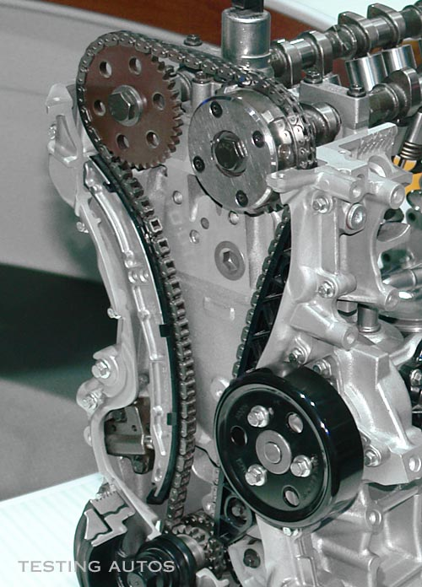Timing Chains: A timing chain is used when the spacing between the crankshaft and camshaft is too large to allow the gears to touch. A chain offers the advantages of being stronger, and not requiring regular replacement. One disadvantage is that a chain must run in oil, so it must be designed to sit inside the engine, which makes access more involved.

2.1.2.8 Spark Plug & Fuel Injector

Figure 9: Timing Chains

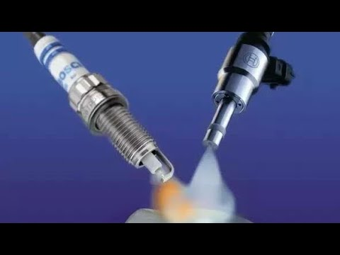**Spark Plug** is a device for delivering electric current from an ignition system to the combustion chamber of a spark-ignition engine to ignite the compressed fuel/air mixture by an electric spark. While the **Fuel Injector** spray **fuel** into a **car's** engine using electronic controlled valves, capable of opening and closing many times a second.

Figure 10: Spark Plug & Fuel Injector

There are two types of injection:

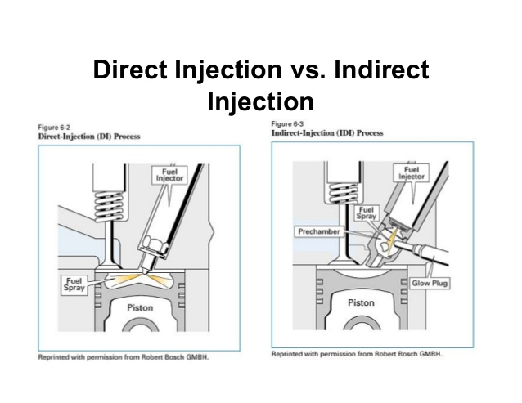**Indirect Injection** in an internal combustion engine is fuel injection where fuel is not directly injected into the combustion chamber.

**Direct injection** directly injects fuel into main combustion chamber which is gap between cylinder and piston where it penetrates into hot mass of compressed air.

Figure 11: Direct & Indirect Injection

2.1.3 Four Stroke Engine

A four-stroke (also four-cycle) engine is an internal combustion (IC) engine in which the piston completes four separate strokes while turning the crankshaft. A stroke refers to the full travel of the piston along the cylinder, in either direction. The four separate strokes are termed:

2.1.3.1 Intake

In this stroke the piston moves downward to the bottom, this increases the volume to allow a fuel-air mixture to enter the chamber.

2.1.3.2 Compression

In this stroke the intake valve is closed, and the piston moves up the chamber to the top. This compresses the fuel-air mixture. At the end of this stroke, a spark plug provides the compressed fuel with the activation energy required to begin combustion.

2.1.3.3 Power

In this stroke as the fuel reaches the end of its combustion, the heat released from combusting hydrocarbons increases the pressure which causes the gas to push down on the piston and create the power output.

2.1.3.4 Exhaust

In this stroke as the piston reaches the bottom, the exhaust valve opens. The remaining exhaust gas is pushed out by the piston as it moves back upwards

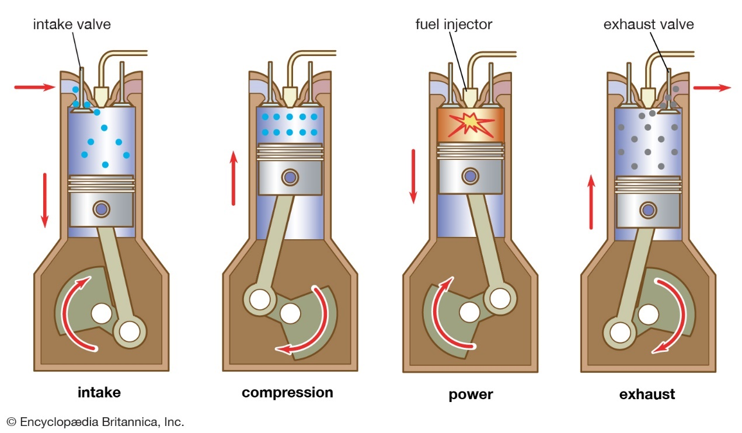

### 3. Fuel pump

A fuel pump is an essential component of the [fuel system](https://www.newkidscar.com/fuel-system/) on a car. Fuel pumps use in carbureted and injected engines. By the depending to where fuel pump are using, they divided on the different types of fuel pumps.

**Purpose of Fuel Pump:**

The Fuel pump`s purpose is supply fuel from [fuel tank](https://www.newkidscar.com/fuel-system/fuel-tank-construction/) to the engine [cylinder](https://www.newkidscar.com/engine-construction/engine-cylinder-construction/). Fuel pump of modern injection systems must create the high pressure, so are often used Electrical fuel pumps.

There are three main types of fuel pumps that your vehicle may be equipped with. Each functions differently so it is important to understand the characteristics of one against another. For example, when shopping for a fuel pump, you will need to know if it pumps the gas into a carburetor or into the **fuel injection system**. Here’s more information on the different types and what they mean for you.

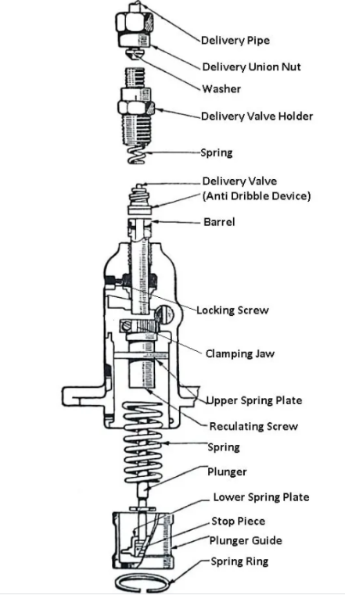

**Fuel pump**

Construction and Working of a Fuel Pump: The plunger is driven by a cam and tappet mechanism at the bottom. The plunger reciprocates in the barrel. There are as many plungers as the number of cylinders in the engine. The plunger has a rectangular vertical groove. The delivery valve is lifted off its seat under the pressure of the fuel against the spring. The fuel from the delivery valve goes to the injector. When the plunger is at the bottom of its stroke, the supply port and spill are uncovered, the fuel from a low-pressure pump after filtration is forced into the barrel.

Now the plunger is pushed up by the cam movement and both the parts are closed. On further movements of the plunger, the fuel above it is compressed which lifts the delivery valve and the fuel through it goes to the injector.

The plunger rises up still further, and at a particular moment, the helical groove connects the spill port, through the rectangular groove to the fuel in the upper part of the plunger. Consequently, there is a sudden pressure drop due to which the delivery valve falls back on its seat under the spring force. The pressure in the delivery pipe also drops. Thus the discharged from the nozzle of the injector is cut off suddenly. The cycle is repeated again and again.

During each stroke of the plunger, the duration of the delivery is more or less according to as the spill port is made to communicate earlier or later, the high-pressure fuel in the upper part of the barrel. This depends upon the position of the helical groove which can be changed by rotating the plunger by the rack.

The rack is connected to the accelerator. It meshes with a geared quadrant. The motion of the rack rotates the gear quadrant which ultimately rotates the plunger. The driver simply operates the accelerator which controls the fuel supply to the engine cylinder.

**Types of Fuel Pumps:** The fuel pump is used in the fuel system to deliver fuel from the fuel tank to [the carburettor.](https://www.theengineerspost.com/types-of-carburetors/) Many types of fuel pumps are used in modern automobile vehicles.

**Low-pressure fuel pumps** – is mounted on the carbureted engines outside the fuel tank;

**High-pressure fuel pumps** – is mounted on diesel and injection engines.

The modern fuel injected engines often use **electric fuel pumps**, which are mounted inside the [**fuel tank**](https://www.newkidscar.com/fuel-system/fuel-tank-construction/).

A fuel pump draws petrol out of the fuel tank by a pipeline to the carburetor, so sometimes it names petrol pump. The mechanical pump has drive from an engine. And electric fuel pump is usually mounted near the tank or inside the tank.

The performance of fuel is tested by pressure, volume and vacuum. A pump must produce certain pressure on the outlet side as specified by the manufacturer. To test a pump for pressure, connect a pressure gauge between the pump and the carburettor and run the engine at a specified speed. The gauge will indicate the pressure created by the fuel pump.

For volume test, disconnect the fuel from the carburettor and run the engine at idling speed. Measure the volume of fuel coming out from the pump by collecting it in a separate container.

For vacuum test, connect a suitable vacuum gauge between the gauge tank and then run the engine at idling speed. The gauge indicates the vacuum generated inside the pump to suck the fuel from the fuel tank.

The vacuum must be retained for at least ten seconds after closing the engine. The fuel pump found connect in the above three tests should be used in the fuel system.

**How a mechanical fuel pump works:**

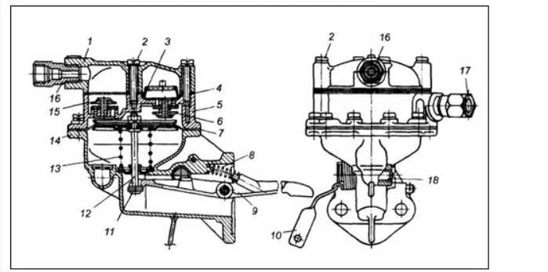

**Fuel pump diagram**

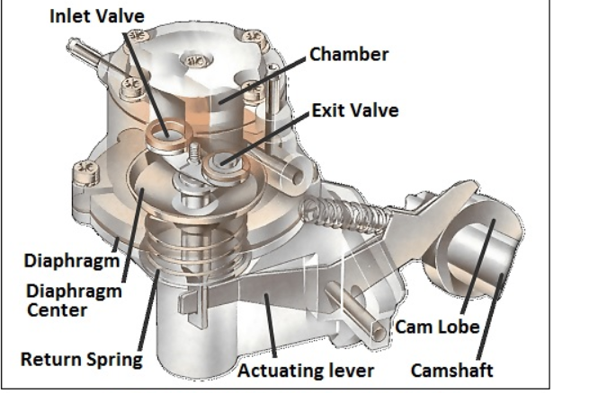

**Mechanical fuel pump**

**How Mechanical pump works:** Mechanical pump`s actuating lever moves up and down during the working. When need to fill the pump chamber lever pulls the diaphragm down.  The return spring moves the diaphragm up to deliver fuel to the carburetor device.

A mechanical fuel pump is driven by the camshaft , or by a special shaft driven by the crankshaft . As the shaft turns, a cam passes under a pivoted lever and forces it up at one end.

The other end of the lever, which is linked loosely to a rubber diaphragm forming the floor of a chamber in the pump, goes down and pulls the diaphragm with it.

When the lever pulls the diaphragm down, it creates suction that draws fuel along the fuel pipe into the pump through a one-way valve .

As the revolving cam turns further, so that it no longer presses on the lever, the lever is moved back by a return spring , relaxing its pull on the diaphragm.

The loosely linked lever does not push the diaphragm up, but there is a return spring that pushes against it.

The diaphragm can move up only by expelling petrol from the chamber. The petrol cannot go back through the first one-way valve, so it goes out through another one leading to the carburettor.

The carburettor admits petrol only as it needs it, through the needle valve in its float chamber (See [How variable-jet carburettors work](https://www.howacarworks.com/basics/how-variable-jet-carburettors-work) ). The first valve is one way, so the petrol cannot move back and moves to the carburetor through another valve.  The carburetor needle valve which mounted into the float chamber regulates admits the petrol as it needs.

In our time by the widespread adoption of electronic fuel injection are used electric fuel pumps. We will talk about electric fuel pumps in next paragraph.

In a mechanical pump the actuating lever moves up and down constantly, but pulls the diaphragm down only as needed to refill the pump chamber. The return spring pushes the diaphragm up to deliver petrol to the carburettor. While the carburettor is full and the needle valve is closed, no petrol leaves the pump. The diaphragm stays down, and the lever idles up and down.

When the carburettor accepts more petrol, the return spring pushes the diaphragm up and, by taking up the slack in the loose linkage, brings it back into contact with the lever, which again pulls it down to refill the pump chamber.

**Electric Fuel Pump:**

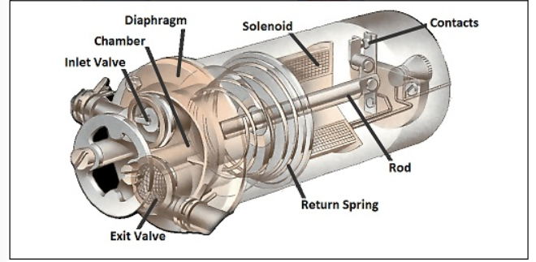

**How Electric Fuel Pump Works:**

An electric pump has a similar diaphragm-and-valve arrangement, but instead of the camshaft, a solenoid (an electromagnetic switch ) provides the pull on the diaphragm.

The solenoid attracts an iron rod that pulls the diaphragm down, drawing petrol into the chamber.

At the end of its travel the iron rod forces apart a set of contacts, breaking the current to the electromagnet and relaxing the pull on the diaphragm.

When the diaphragm return spring raises the diaphragm, it also pulls the rod away from the contacts; they then close so that the solenoid pulls the rod and diaphragm down again.

Circulating petrol continuously:

Most mechanical and electrical systems pump fuel only when the carburettor needs it. An alternative system has a complete circuit of pipes, from the tank to the carburettor and back again. The pump sends petrol continuously round this circuit, from which the carburettor draws petrol as it needs it

## 3.2 Electrical

### 3.2.1 Ignition Coil

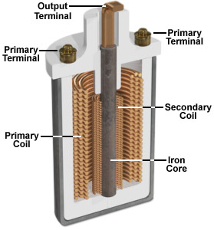Now most automobiles run on gasoline, which they burn in an internal combustion engine to convert into motion. For combustion to take place, a spark is needed to ignite the fuel mixture in the engine. The vehicle’s ignition system is designed so that a 12-volt battery can generate the very high voltage required to create such a discharge. The heart of this system is a device called an ignition coil.

Figure : Internal of ignition coil

This coil is a kind of transformer. Transformers transfer voltage from one circuit to another, either as a higher voltage (as in a step-up transformer, of which the ignition coil is an example), or a lower voltage (a step-down transformer). The key principle that makes transformers work is electromagnetic induction: a moving magnetic field, or a change in a stationary magnetic field (the case in our ignition coil), can induce a current in a wire exposed to that field.

This ignition coil is a pulse-type transformer. Like other transformers, it consists, in part, of two coils of wire. These are both wrapped around the same iron core. Because this is a step-up transformer, the secondary coil has far more turns of wire than the primary coil, which is wrapped around the secondary. In fact, the secondary coil has several thousand turns of thin wire, whereas the primary coil has just a few hundred. In your car, this allows some 40,000 volts of electricity to be generated by a modest battery.

**The basic principle of an ignition coil**

To produce the required high voltages, ignition coils make use of the relationships that exist between electricity and magnetism.

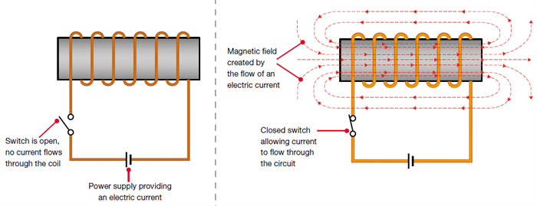When an electric current flow through an electrical conductor such as a coil of wire, it creates a magnetic field around the coil. The magnetic field (or, more precisely, magnetic flux) is effectively a store of energy, which can then be converted back into electricity.

Figure : Creating a magnetic field by flowing electric current through a coil

When the electric current is initially switched on, the current flow rapidly increases to its maximum value. Simultaneously, the magnetic field or flux will progressively grow to its maximum strength, and will become stable when the electric current is stable. When the electric current is then switched off, the magnetic field will collapse back in towards the coil of wire.

**There are two main factors that affect the strength of the magnetic field:**

1. Increasing the current being applied to the coil of wire strengthens the magnetic field
2. The higher number of windings in the coil, the stronger the magnetic field.

**Operation of Ignition coil**

For ignition coils (and many types of electrical transformer), the secondary winding is made with more windings than the primary winding. When the magnetic field collapses, it will therefore induce a higher voltage into the secondary winding than into the primary winding.

The secondary winding has more coils than the primary winding. When the magnetic field collapses, the voltage in the secondary coil will be greater than the voltage induced in the primary winding.

The primary winding of an ignition coil will typically contain 150 to 300 turns of wire; the secondary winding will typically contain 15,000 to 30,000 turns of wire, or around 100 times more than the primary winding.

The magnetic field is initially created when the vehicle’s electrical system applies approximately 12 volts to the ignition coil’s primary winding. When a spark is required at a spark plug, the ignition system will switch off the current flow to the primary winding, which will cause the magnetic field to collapse. The collapsing magnetic field will induce a voltage into the primary winding in the region of 200 volts, but the voltage induced into the secondary winding will be approximately 100 times greater, around 20,000 volts.

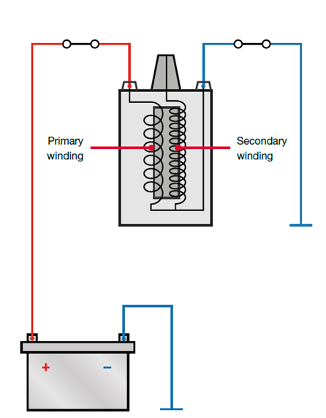By using the effects of mutual inductance and by using a secondary winding that has 100 times more windings than the primary winding, it is therefore possible to transform the original 12-volt supply into a very high voltage. This process of changing a low voltage into a high voltage is referred to as the ‘transformer action

In an ignition coil, the primary and secondary windings are wrapped around an iron core, which helps concentrate and enhance the strength of the magnetic field and flux, thus making the ignition coil more efficient.

.

Figure : Operation of Ignition coil

**WASTED SPARK IGNITION SYSTEMS**

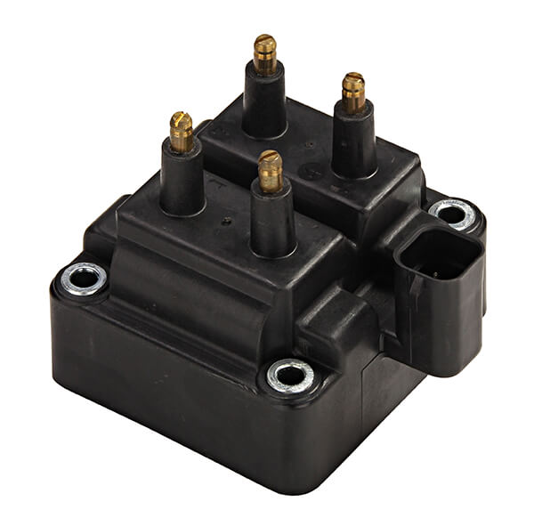Wasted spark ignition systems are a type of DIS, which uses one coil for every two cylinders. The coil provides the spark for one of the paired cylinders on the compression stroke and to the other on the exhaust stroke. Because the coil fires the spark plug on the exhaust stroke as well, it is appropriately named 'wasted spark ignition'. In effect, the spark plugs fire simultaneously and twice as often.

Figure : WASTED SPARK IGNITION COIL

Ignition Coil One of the two paired spark plugs is always negative polarity while the other spark plug is always positive polarity. Negative polarity means the spark plug's center electrode is negatively charged and its ground electrode is positively charged. Positive polarity is the opposite. Each time the plug fires, a rapid exchange of the protons and electrons occurs, called ionization.

The negatively charged electrons will be attracted to whichever side of the spark plug that is positively charged. The positively charged protons have much more mass than electrons, and thus cause more wear on the electrode they collide with. Hence, one plug will exhibit more wear on its ground electrode, while the other plug will experience more wear on its center electrode. If a spark plug with a precious metal on only the center electrode were to be used with this type of ignition system, there would be uneven wear on half the plugs. Although single precious metal or standard nickel plugs will still allow the engine to run, plug life will be greatly reduced.

Therefore, if a vehicle was originally equipped with dual precious metal spark plugs, replacement with a single precious metal or standard nickel plug may reduce plug life and engine performance.

In a four-cylinder engine, for example, cylinders 1 and 4 are connected to one ignition coil, and cylinders 2 and 3 to another. The ignition coils are triggered by the ignition output stages in the electronic control unit. This receives the TDC signal from the [crankshaft sensor](https://www.hella.com/techworld/uk/Crankshaft-sensor-4506/) in order to begin triggering the correct ignition coil.

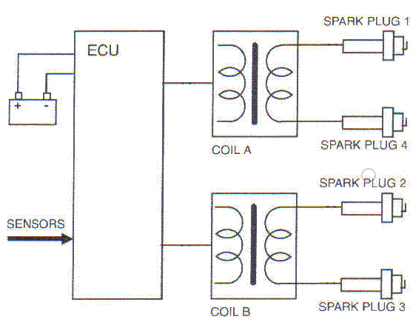

Figure : WASTED SPARK IGNITION SYSTEMS

**The advantage of Wasted spark ignition systems**

That no distributor is needed, so there is no mechanical parts, wear or voltage drops. As a result, the coil needs less energy so can be made smaller. Usually in a 4-cylinder engine we’ll have two coils in one body – coil pack.

**The disadvantage of Wasted spark ignition systems**

Is that there is firing in the exhaust strokes which implies that no fuel mixture may enter at that time because of valve overlap or any other reason. Otherwise, the fuel mixture will explode in the cylinder when is it at exhaust stroke and coarse damage to the engine. As result it is not always possible to get an optimum ignition timing. The other disadvantage is that those systems are more difficult to diagnose than the other ignition systems.

### 3.2.3 Spark Plug

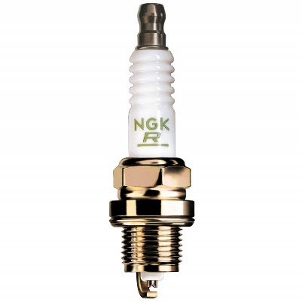A spark plug is an electrical device that fits into the cylinder head of some internal combustion engines and ignites compressed aerosol gasoline by means of an electric spark. Spark plugs have an insulated center electrode which is connected by a heavily insulated wire to an ignition coil or magneto circuit on the outside, forming, with a grounded terminal on the base of the plug, a spark gap inside the cylinder. Internal combustion engines can be divided into spark-ignition engines, which require spark plugs to begin combustion.

Figure : Spark Plug

* **The spark plug has two primary functions**

1. To ignite the air/fuel mixture. Electrical energy is transmitted through the spark plug, jumping the gap in the plugs firing end if the voltage supplied to the plug is high enough. This electrical spark ignites the gasoline/air mixture in the combustion chamber. To remove heat from the combustion chamber. Spark plugs cannot create heat, they can only remove heat. The temperature of the end of the plug\'s firing end must be kept low enough to prevent pre-ignition, but high enough to prevent fouling.
2. The spark plug works as a heat exchanger by pulling unwanted thermal energy from the combustion chamber and transferring heat to the engines cooling system. The heat range of a spark plug is defined as its ability dissipate heat from the tip.

* **Operation of Spark plug**

The plug is connected to the high voltage generated by an ignition coil or magnet. As the electrons flow from the coil, a voltage difference develops between the center electrode and side electrode. No current can flow because the fuel and air in the gap is an insulator, but as the voltage rises further, it begins to change the structure of the gases between the electrodes. Once the voltage exceeds the dielectric strength of the gases, the gases become ionized. The ionized gas becomes a conductor and allow electrons to flow across the gap. Spark plugs usually require voltage in excess of 20,000 volts to 'fire' properly.

As the current of electrons surges across the gap, it raises the temperature of the spark channel to 60,000 K. The intense heat in the spark channel causes the ionized gas to expand very quickly, like a small explosion. This is the "click" heard when observing a spark, similar to lightning and thunder.

The heat and pressure force the gases to react with each other, and at the end of the spark event there should be a small ball of fire in the spark gap as the gases burn on their own. The size of this fireball or kernel depends on the exact composition of the mixture between the electrodes and the level of combustion chamber turbulence at the time of the spark. A small kernel will make the engine run as though the ignition timing was retarded, and a large one as though the timing was advanced.

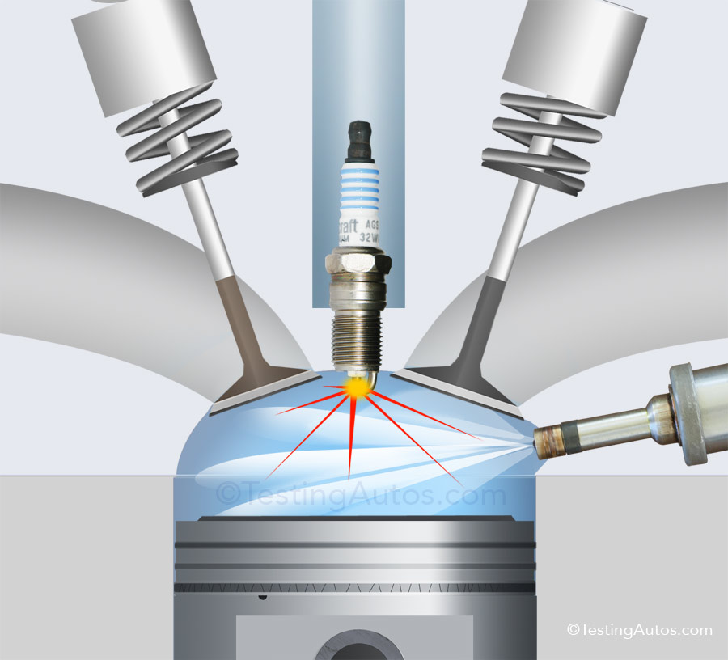

Figure : Operation of spark plug